Assignment 1B: JavaScript AJAX Implementation

Name: Atharva Agrawal
RollNo: 33303
Batch: K-11

Sending Values:

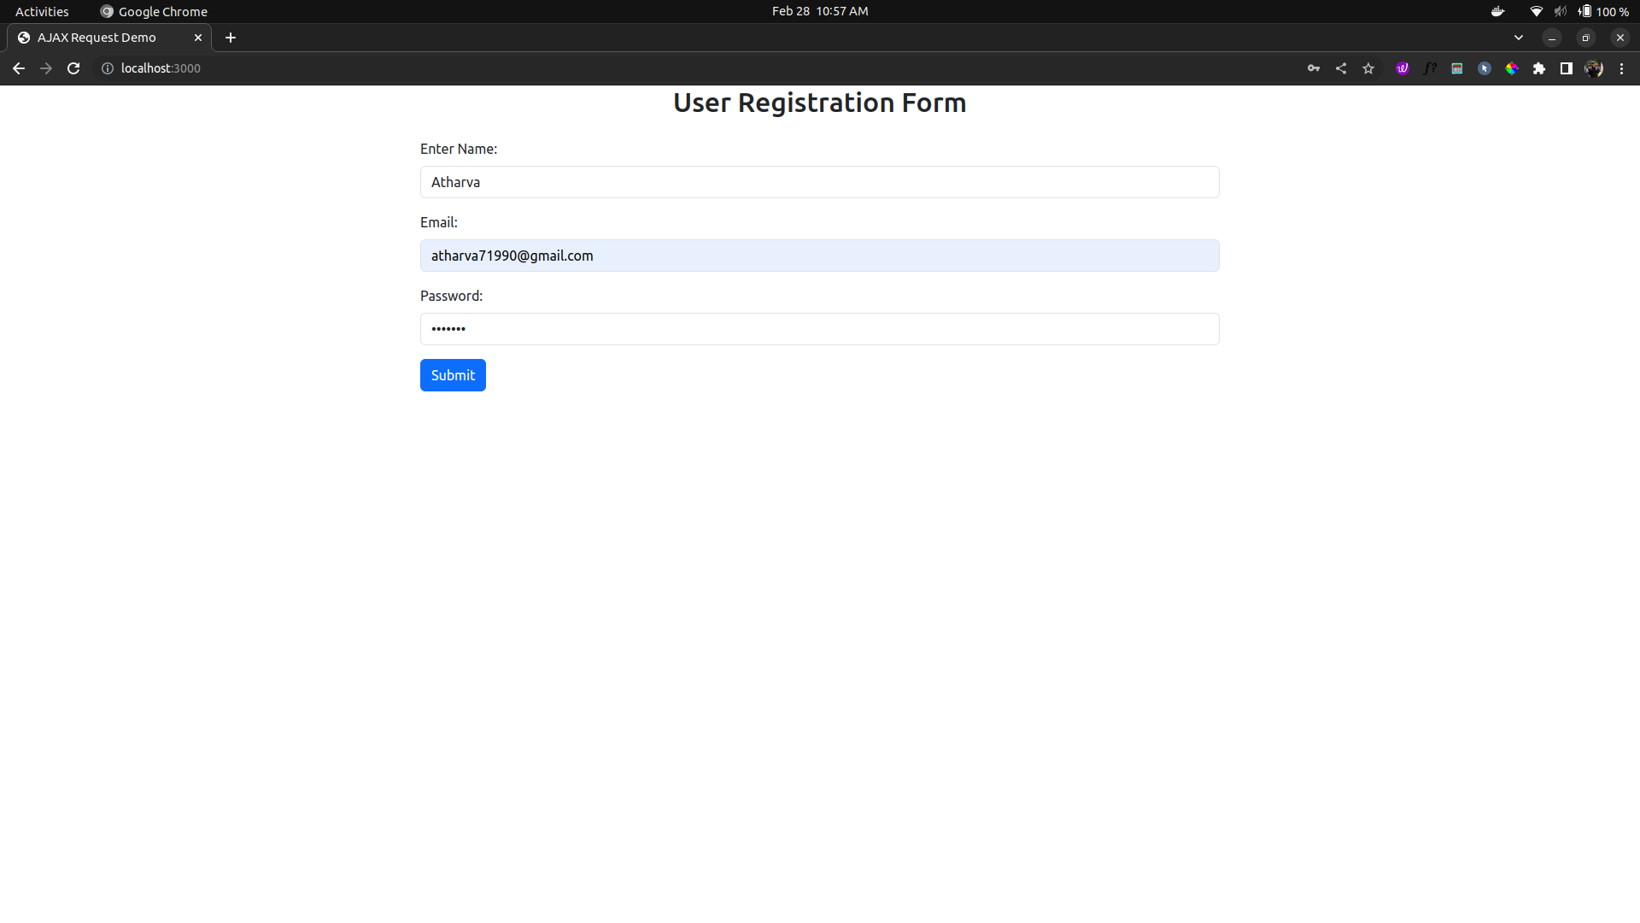
Received Data:

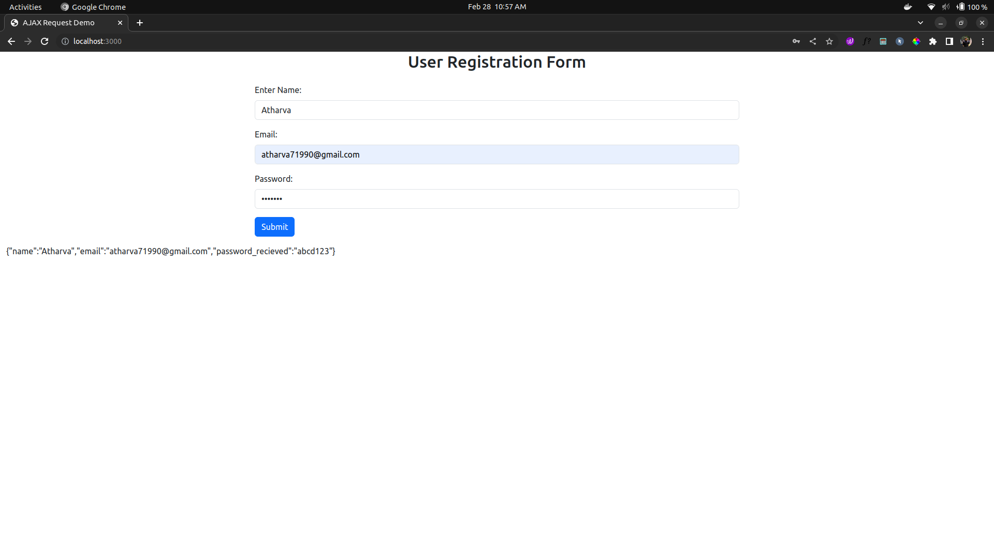

Server Running:

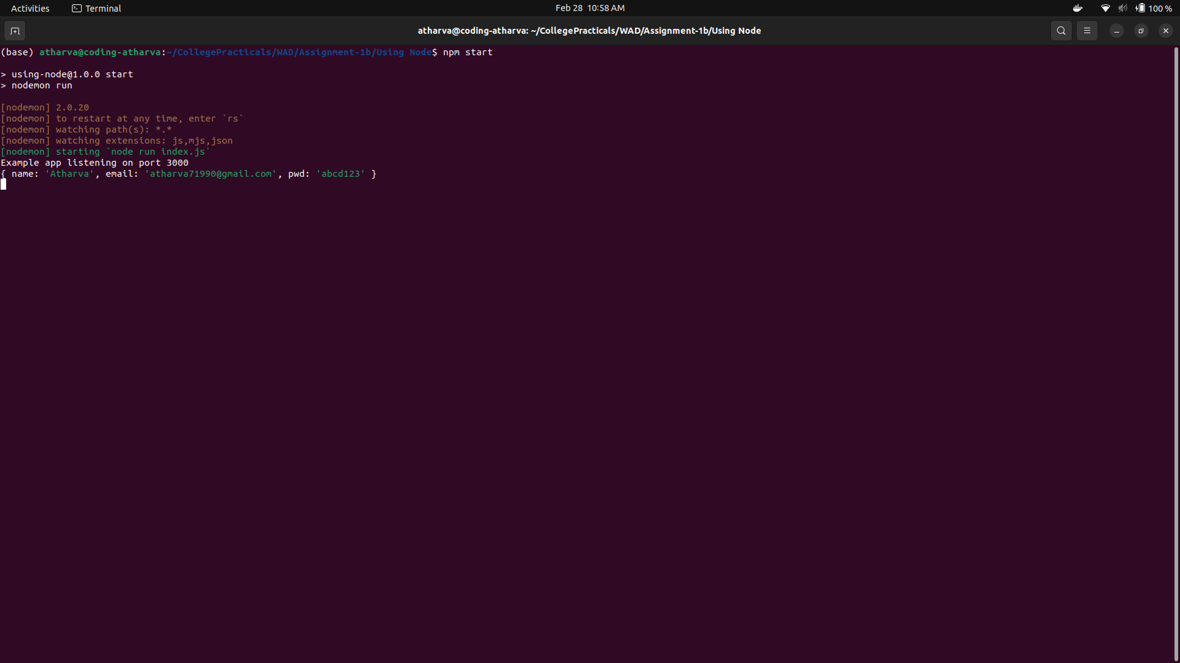

NodeJS Server Code:

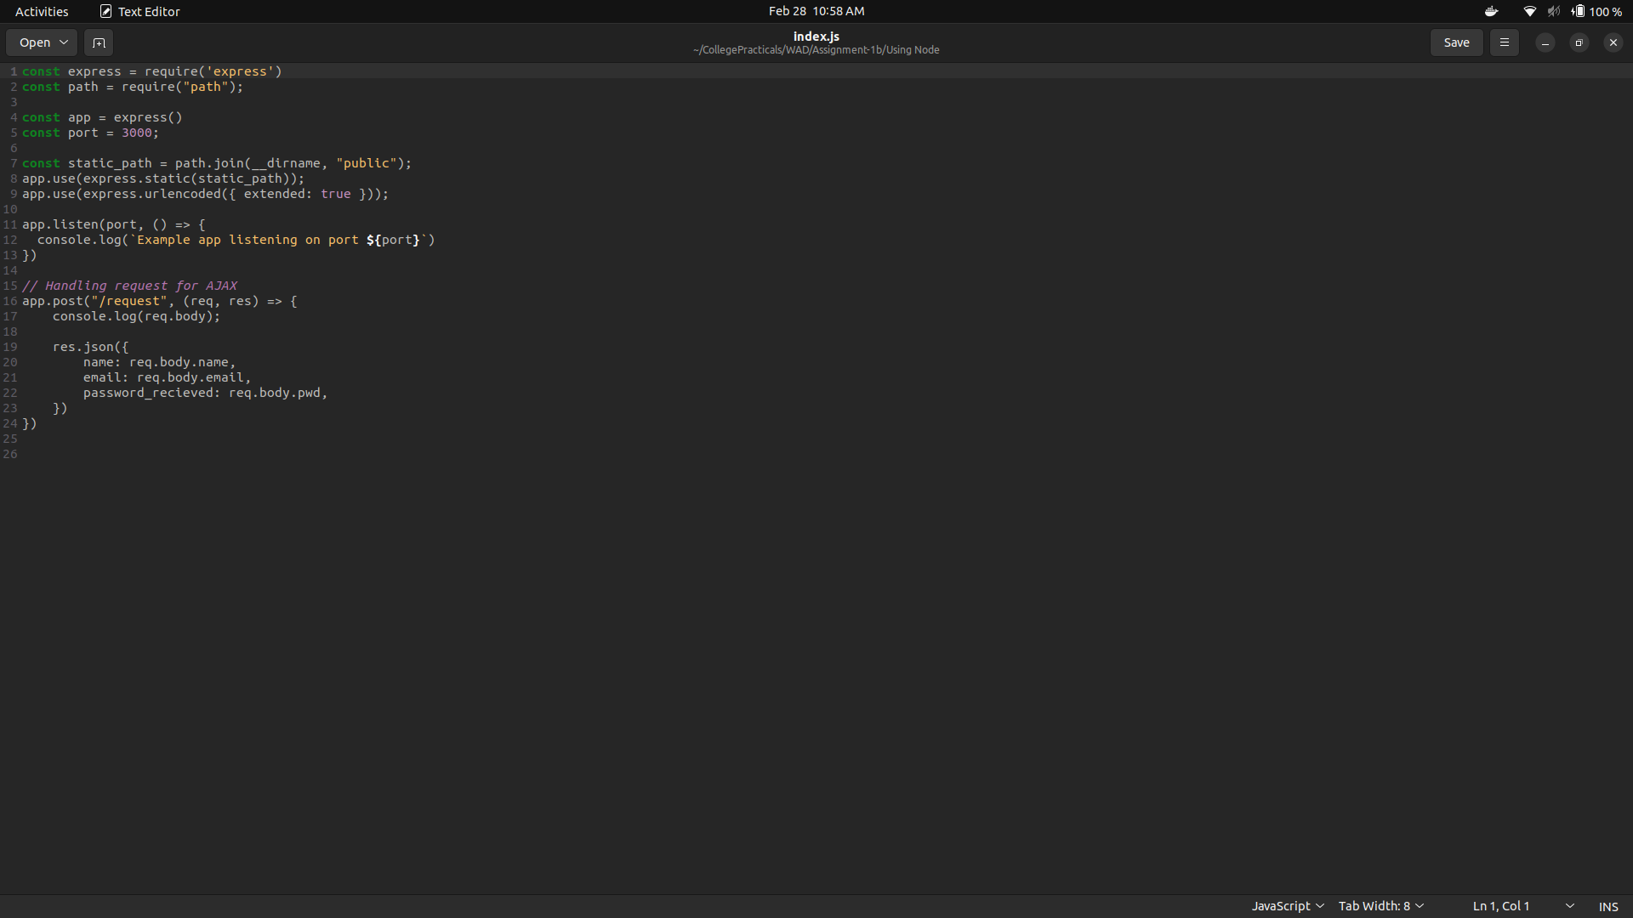

AJAX Code:

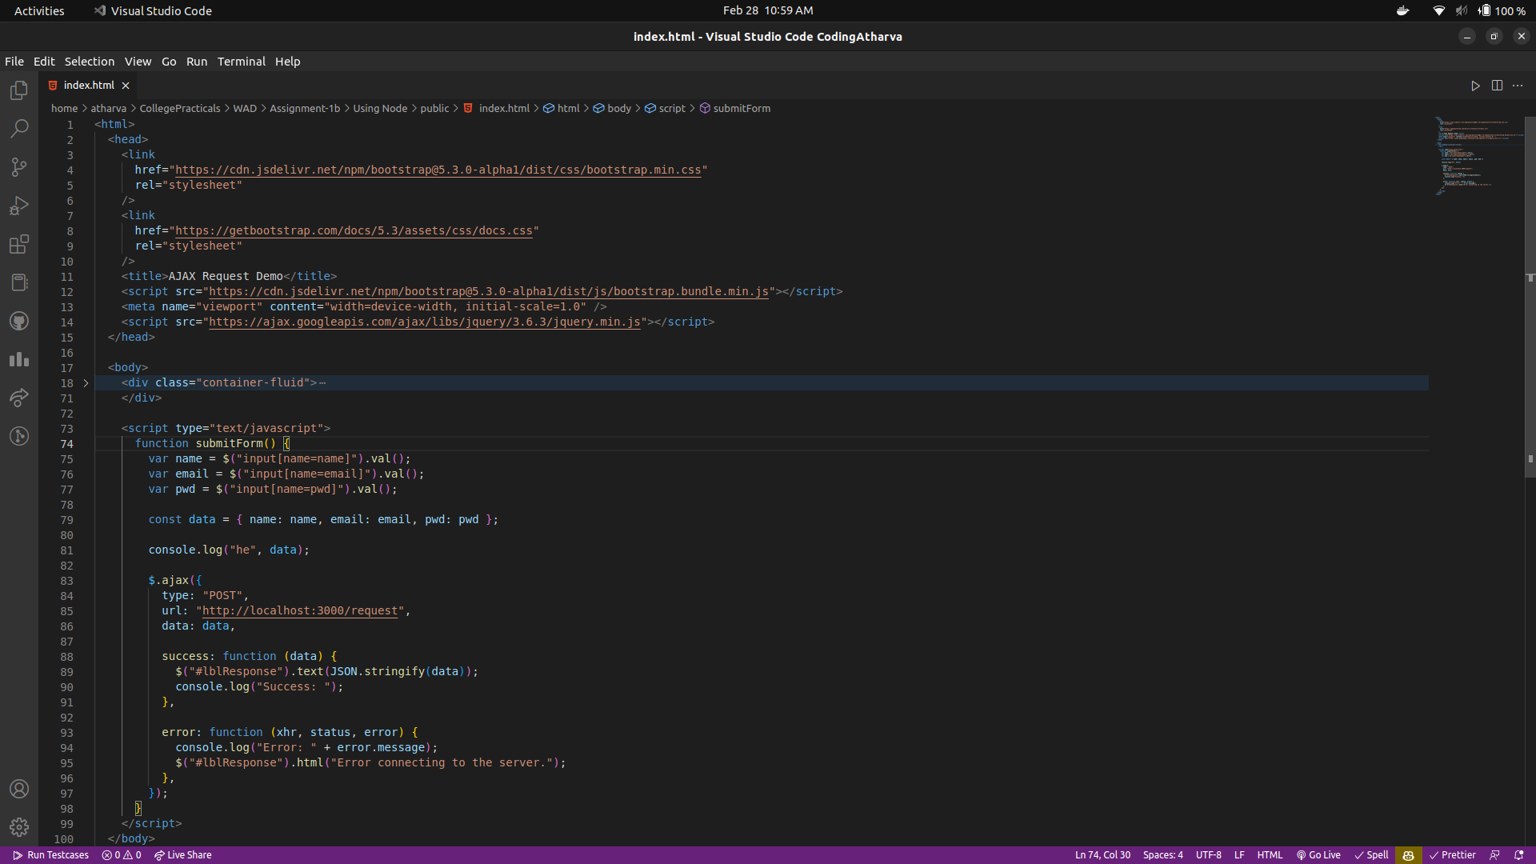

XMLHTTP Code:

